Go to google and write “atom”. Go to <https://atom.io/> to download atom IDE. Click on “Download”

It.

Right click on the setup file and select “Run as administrator”.

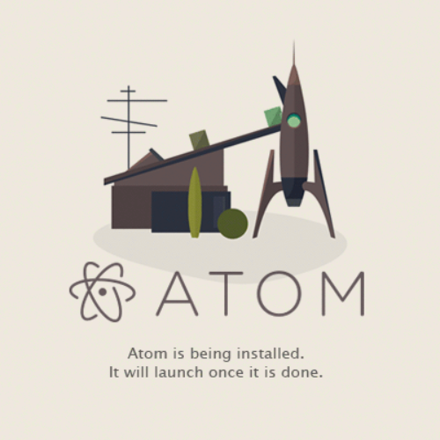

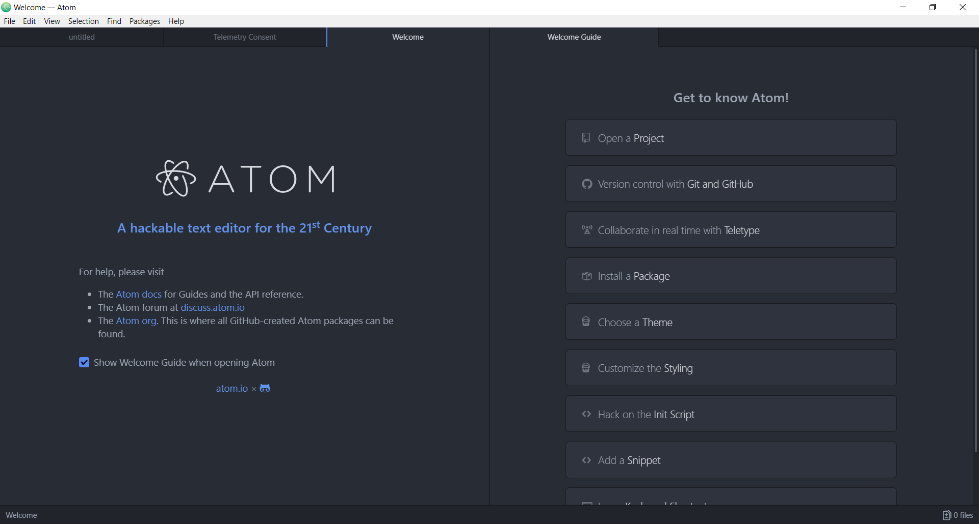

python –version

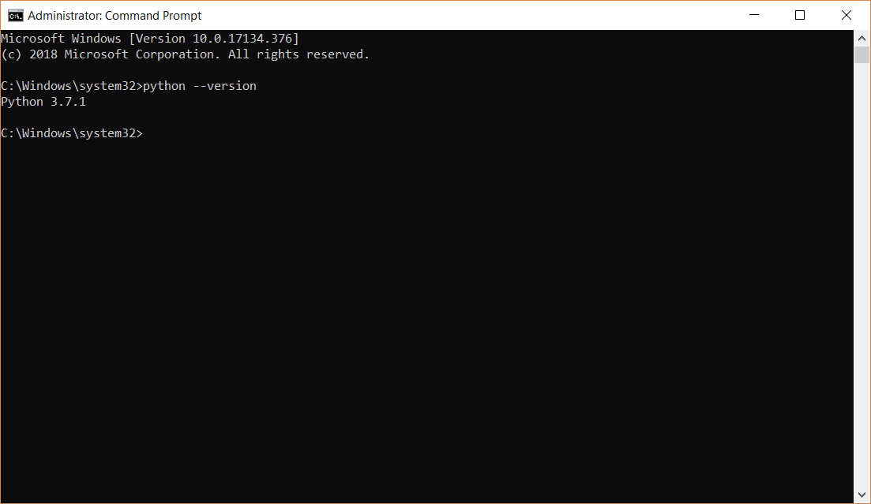

<https://docs.djangoproject.com/en/2.1/faq/install/> -> latest version is 2.2

pip install Django==2.2

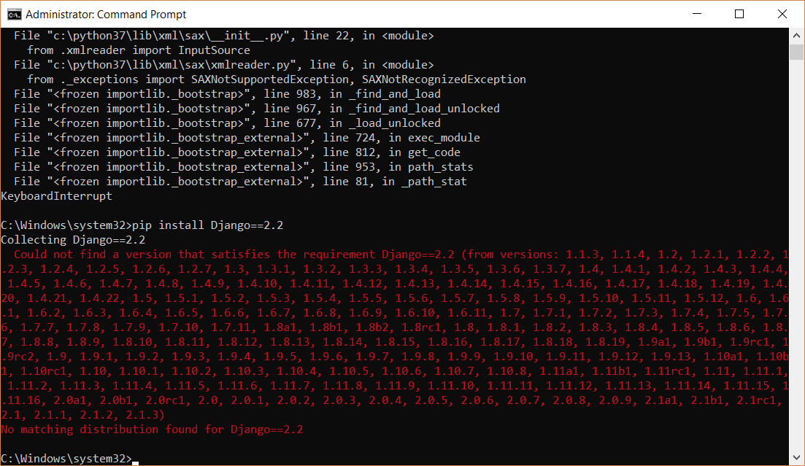

Since the latest version is 2.1.3 we can write pip install Django==2.1.3 or pip install Django. This installs the latest version.

pip install Django

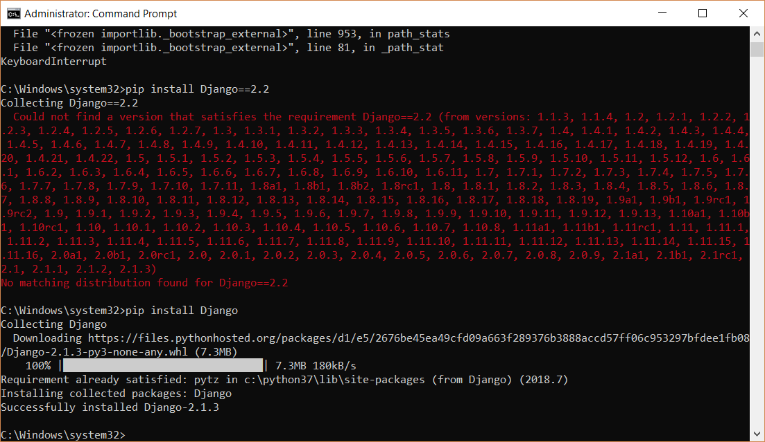

To verify the version of Django installed:-

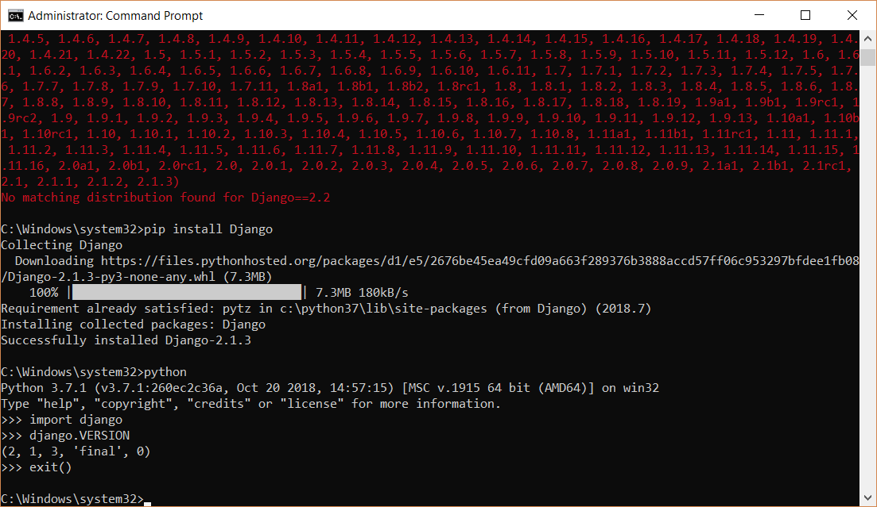

Creating Project:-

In C:\MSc\Project create a folder:- webapp

cd..

cd..

cd MSc

cd Project

cd webapp

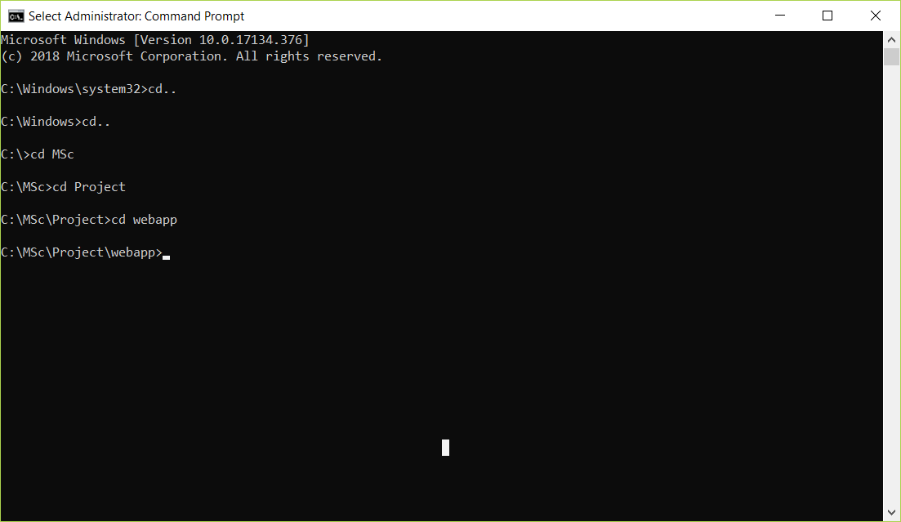

django-admin startproject website

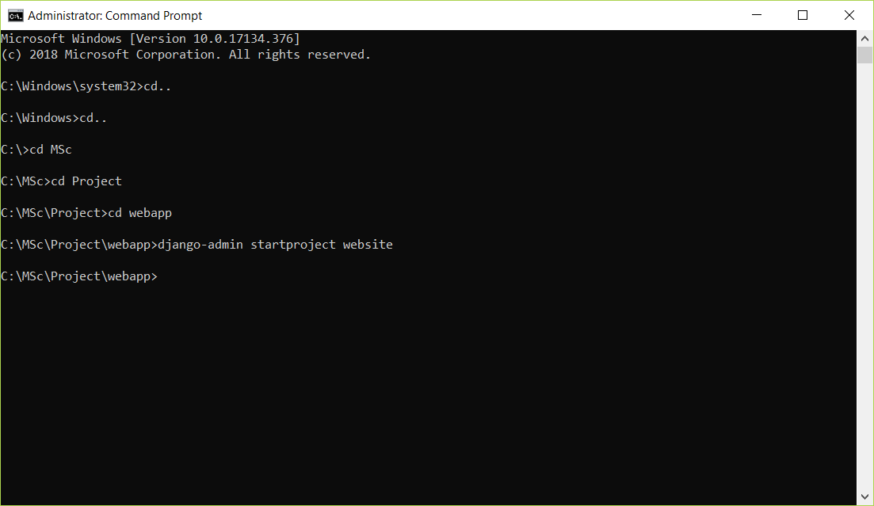

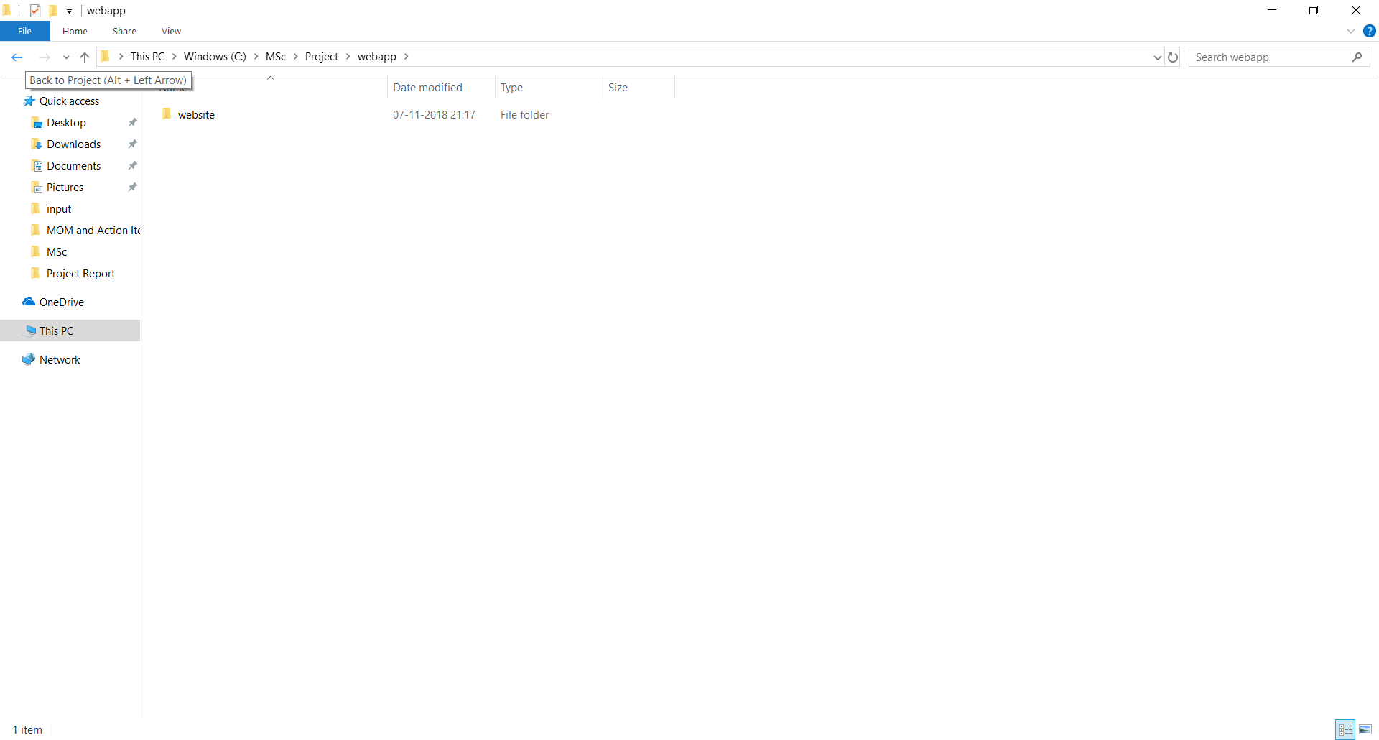

Open Atom IDE.

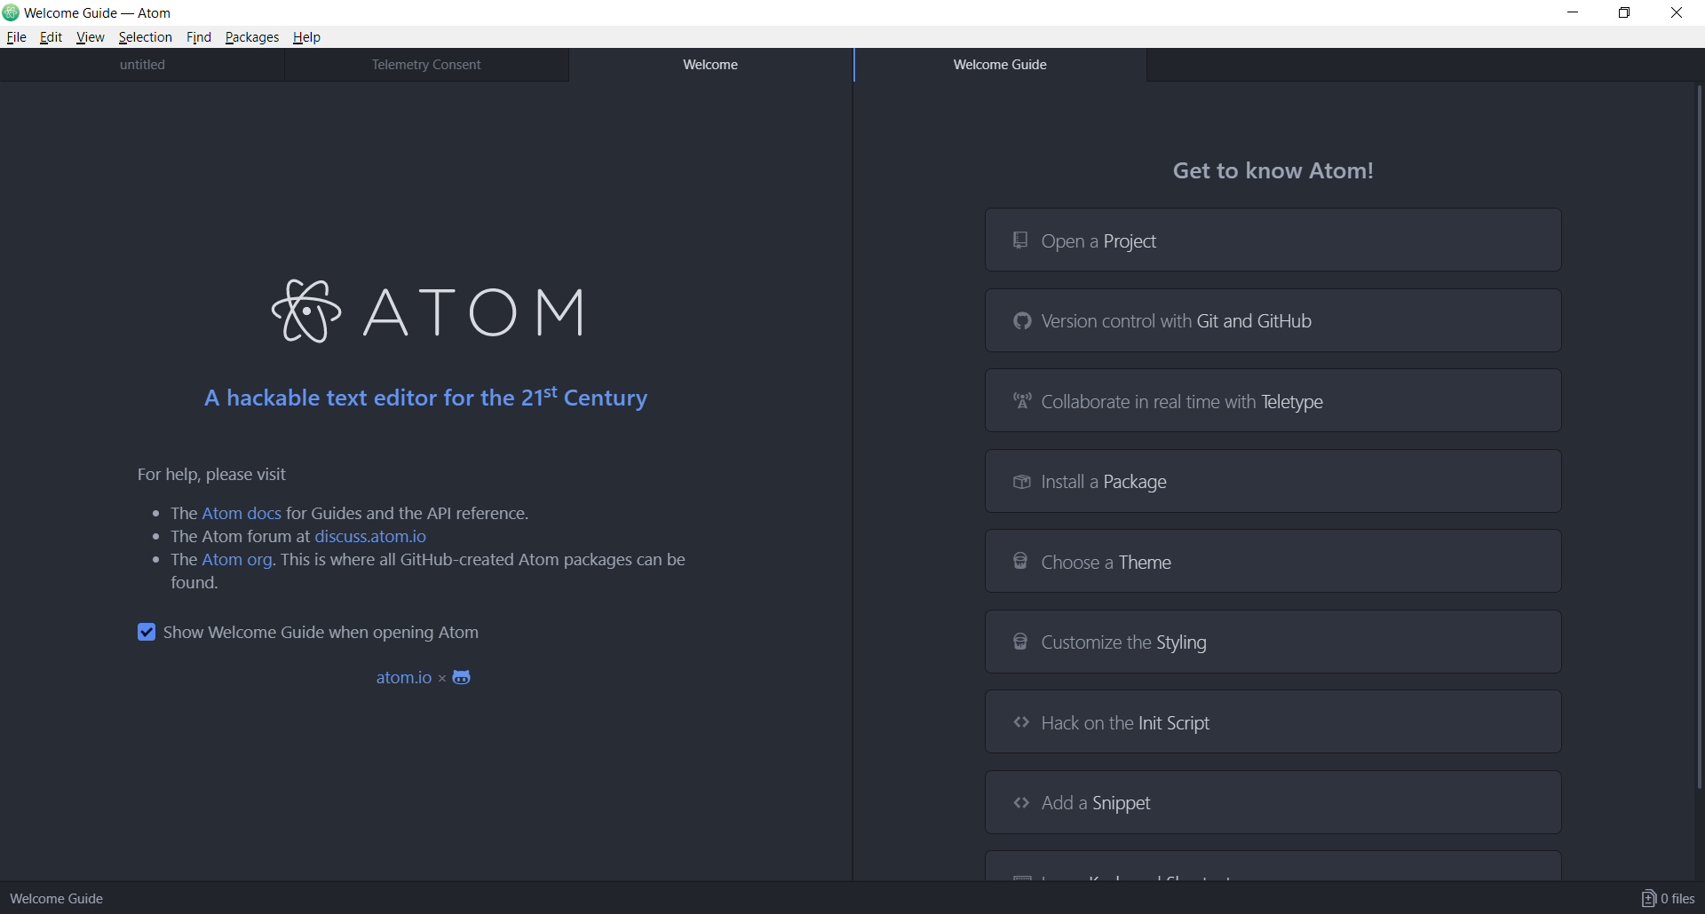

Drag and drop this in Atom IDE.

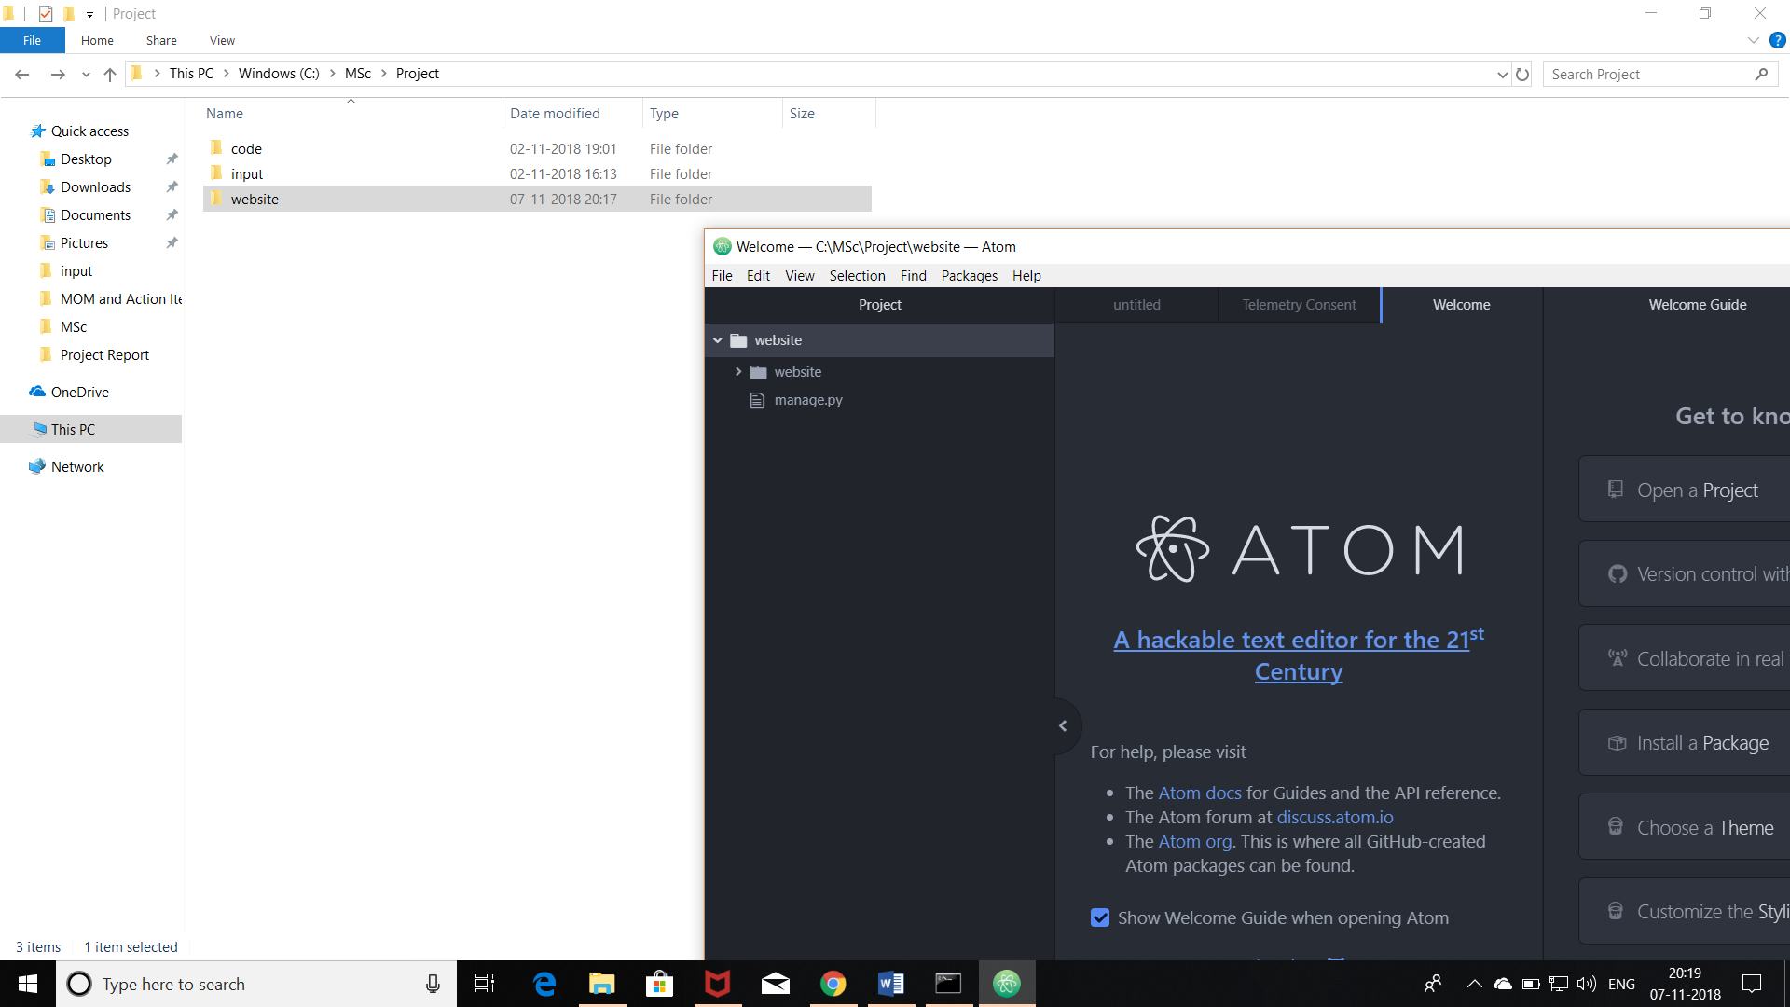

cd website

dir

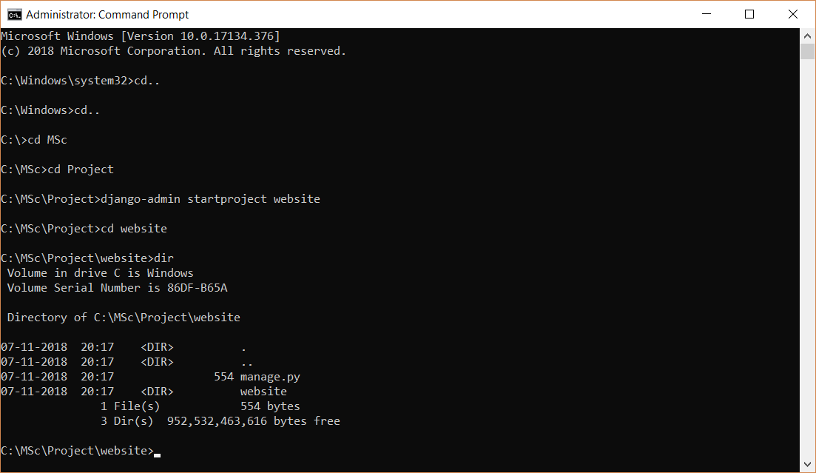

python manage.py runserver

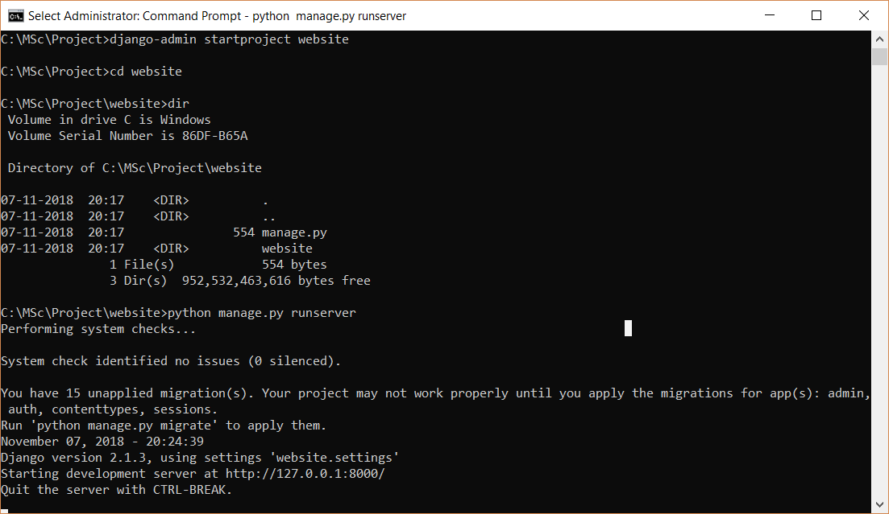

Go to : <http://127.0.0.1:8000/>

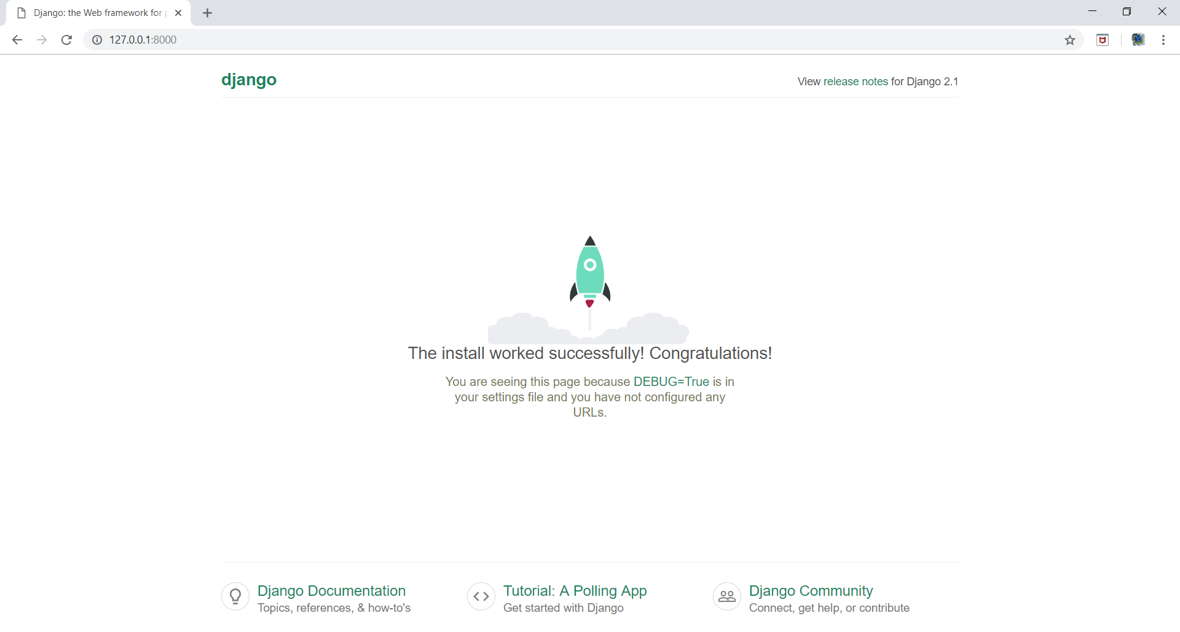

This means the setup is done correctly. Press Ctrl+C twice to stop the development server. Dir command gives a listing of all files.

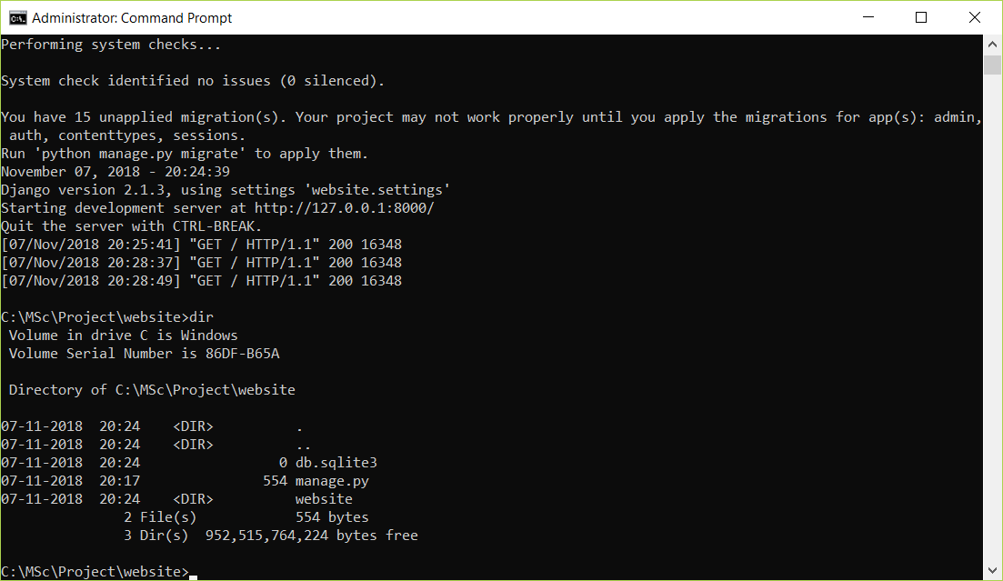

python manage.py startapp home

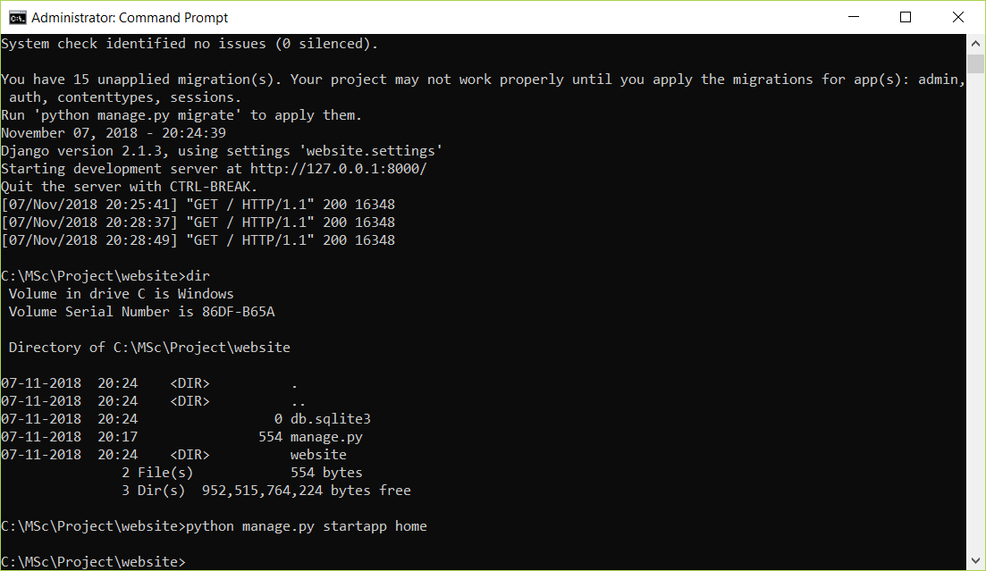

We need to inform the base project about the app. So in the “website” settings.py file, add home in INSTALLED_APPS as:-

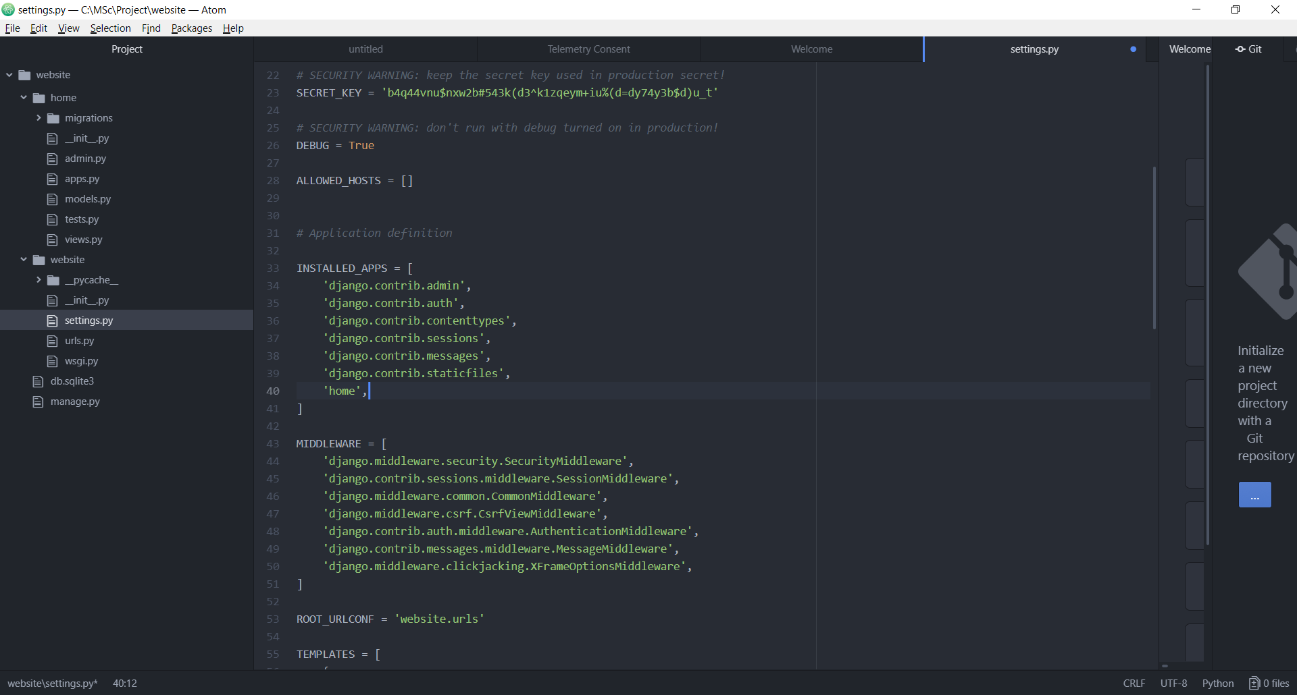

Creating templates:-

Right click on “website” and select New Folder and give name as “templates”.

Right click on templates and select New File and give name as “home.html”

In home.html, write the following:- <h1> This is my home page </h1>

In “website” settings.py file, edit the TEMPLATES DIR from [] to the highlighted one as:-

